Services-elastic-kibana,
Install java 21
sudo apt update
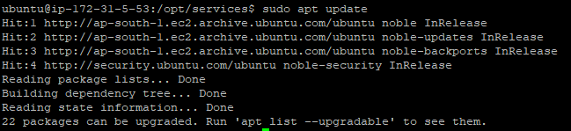
sudo apt install openjdk-21-jdk
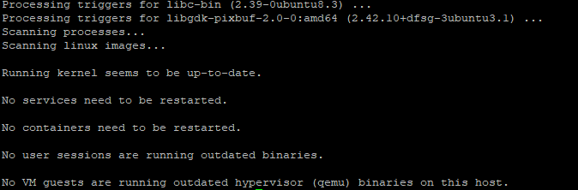
Java -version
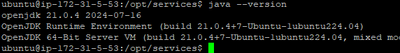

Elastic search installation,
Sudo apt update
sudo wget https://artifacts.elastic.co/downloads/elasticsearch/elasticsearch-8.15.0-linux-x86_64.tar.gz
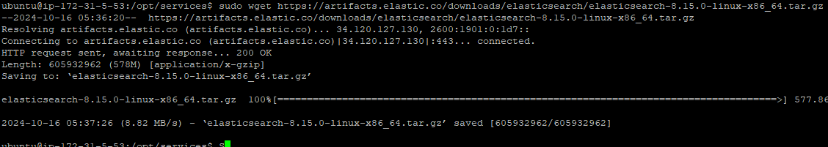
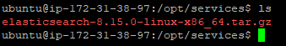
Zip to unzip,
sudo tar -xzf elasticsearch-8.15.0-linux-x86_64.tar.gz
and go to the elasticksearch then config file after conguration,
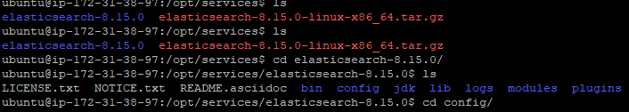

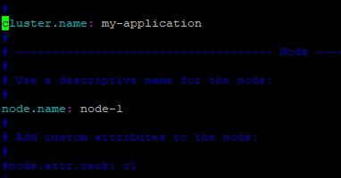

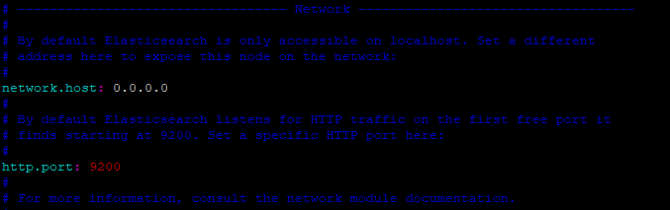

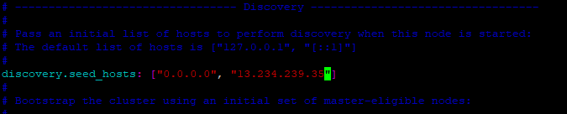

sudo vi jvm.options
Enable to the this one -XMS1G,
In this file before -XMS4g after XMS1g,
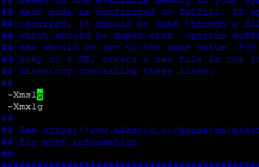

sudo vi /etc/systemd/system/elasticsearch-elasticsearch.service
Add this down content to the upper path,
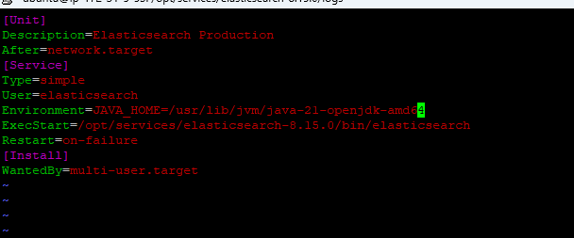
[Unit]
Description=Elasticsearch Production
After=network.target
[Service]
Type=simple
User=elasticsearch
Environment=JAVA_HOME=/usr/lib/jvm/java-21-openjdk-amd64
ExecStart=/opt/services/elasticsearch-8.15.0/bin/elasticsearch
Restart=on-failure
[Install]
WantedBy=multi-user.target

[Or]

[Unit]
Description=Elasticsearch Production
After=network.target

[Service]
Type=simple
User=elasticsearch
Group=elasticsearch
Environment=JAVA_HOME=/usr/lib/jvm/java-21-openjdk-amd64
ExecStart=/opt/invoice_services/elasticsearch-8.15.0/bin/elasticsearch
Restart=on-failure

[Install]
WantedBy=multi-user.target

sudo systemctl daemon-reload
sudo systemctl start elasticsearch-elasticsearch.service
sudo systemctl status elasticsearch-elasticsearch.service
displaying to the like this error,
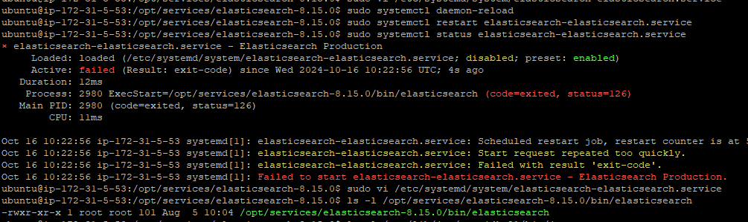
give the some permission,
sudo chmod +x /opt/services/elasticsearch-8.15.0/bin/elasticsearch
sudo chown -R elasticsearch:elasticsearch /opt/services/elasticsearch-8.15.0
printenv | grep JAVA_HOME
sudo systemctl daemon-reload
sudo systemctl start elasticsearch-elasticsearch.service
sudo systemctl status elasticsearch-elasticsearch.service

sudo ufw status
Sudo ufw enable
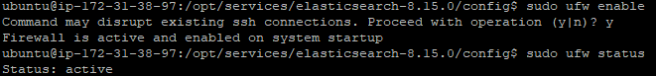
Sudo ufw allow 9200
Sudo ufw status
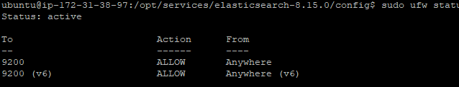

Out put elastic search, “https://13.233.155.118:9200”
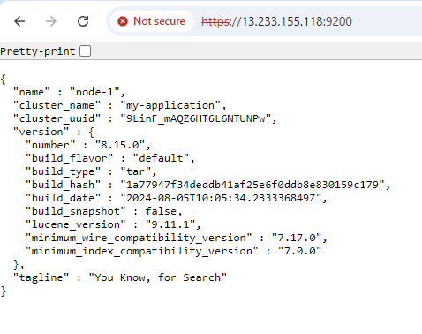

With out https
Ssl setes

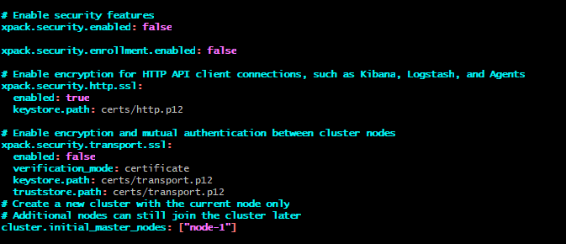

# Enable security features
xpack.security.enabled: false

xpack.security.enrollment.enabled: false

# Enable encryption for HTTP API client connections, such as Kibana, Logstash, and Agents
xpack.security.http.ssl:
enabled: true
keystore.path: certs/http.p12

# Enable encryption and mutual authentication between cluster nodes
xpack.security.transport.ssl:
enabled: false
verification_mode: certificate
keystore.path: certs/transport.p12
truststore.path: certs/transport.p12
# Create a new cluster with the current node only
# Additional nodes can still join the cluster later
cluster.initial_master_nodes: ["node-1"]

Kibana installation on ubuntu,
First we need java 21 version after you can installa kibana,
Install java 21
sudo apt update


sudo apt install openjdk-21-jdk


Java-version


wget https://artifacts.elastic.co/downloads/kibana/kibana-8.10.2-amd64.deb
ls
sudo dpkg -i kibana-8.10.2-amd64.deb
sudo apt-get install -f

